**Power BI Assignment 4**

1. Make a simple dashboard and show columns, bar charts, line charts, and area charts.

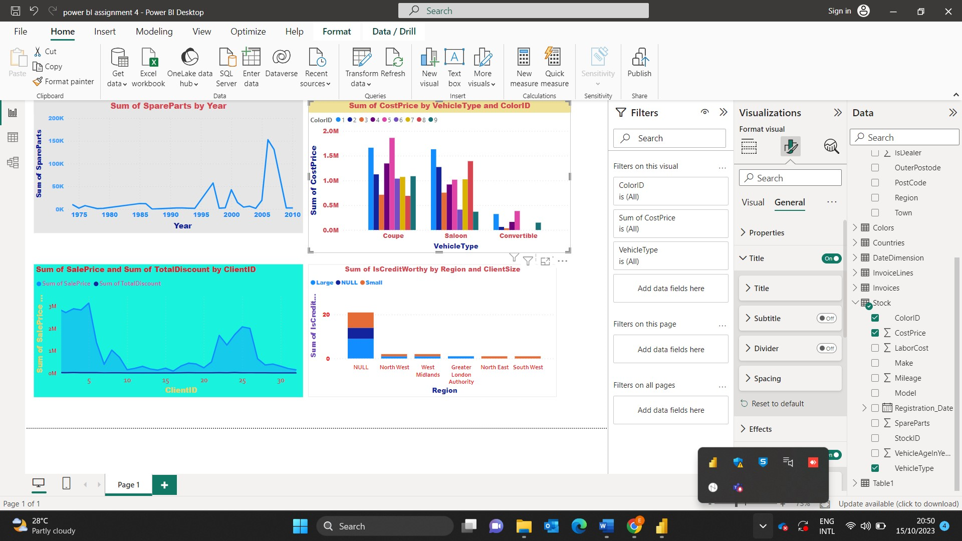

1. Make a simple dashboard and show combination chart, Scatter chart, Shape chart, and Treemap chart.

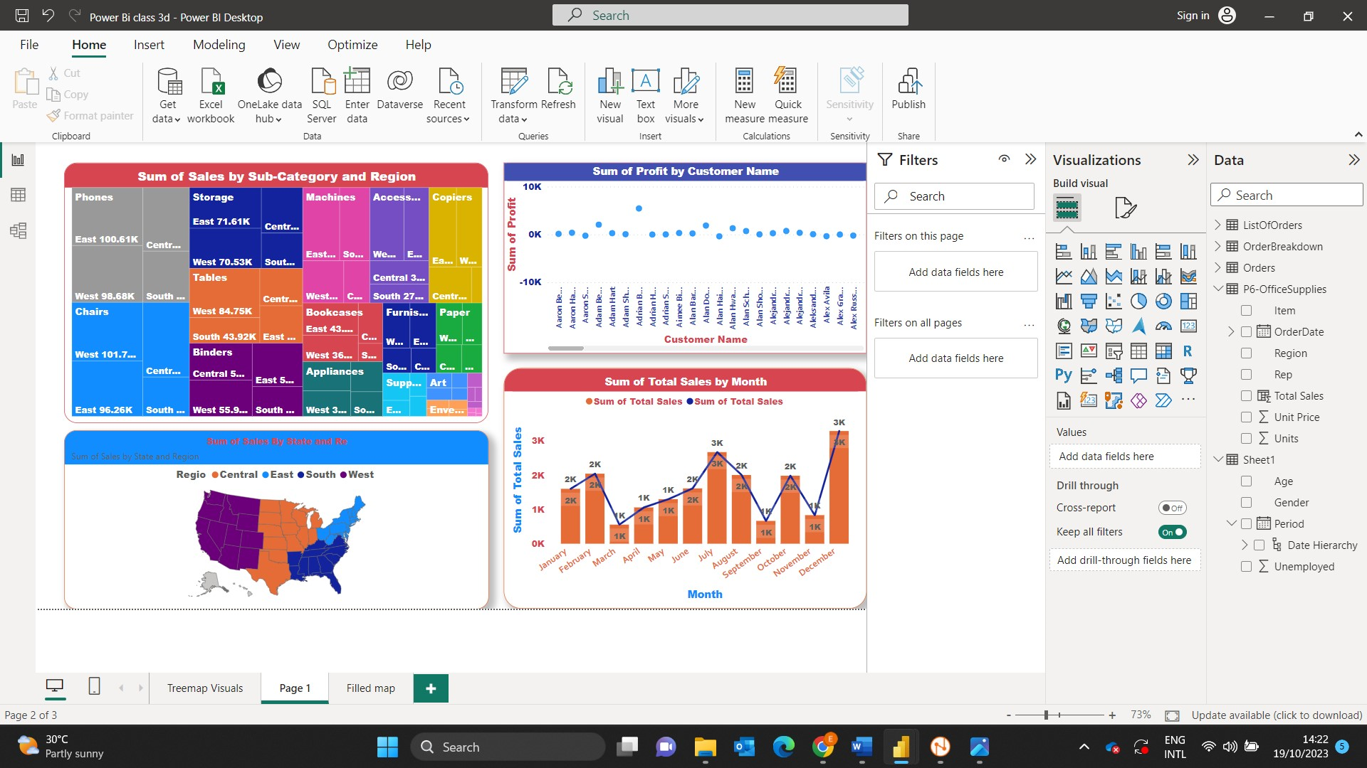

1. Make a dashboard and show 2 maps visualization i.e., basic map

and filler maps.

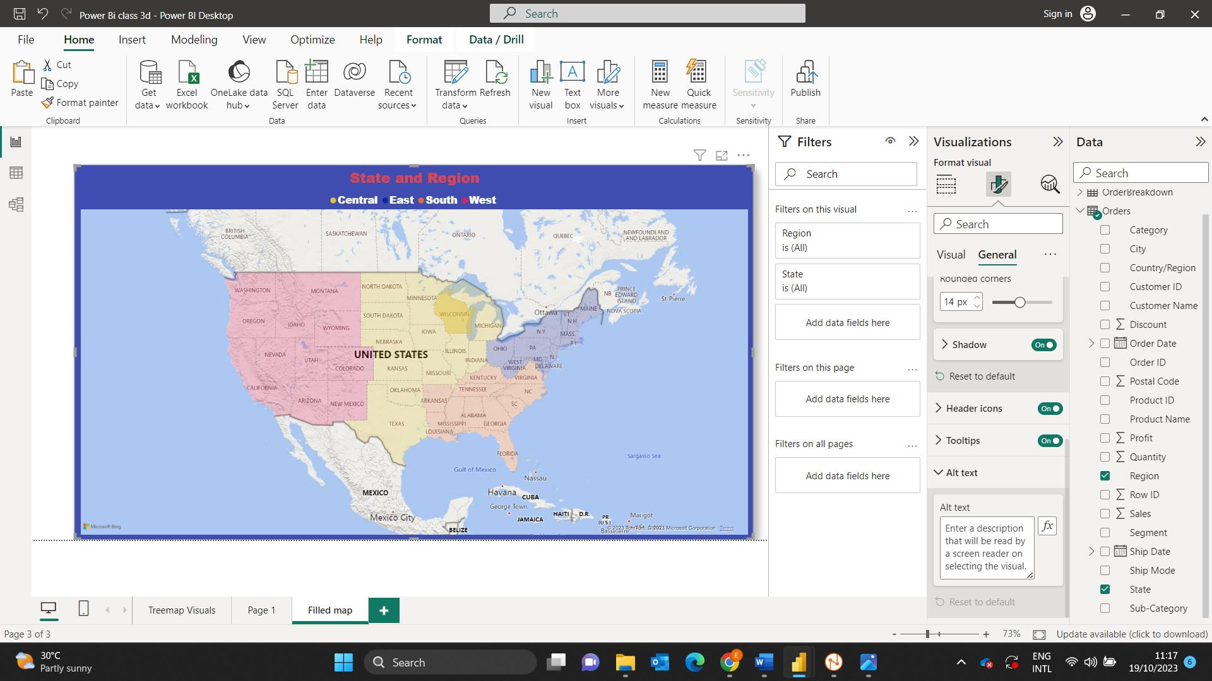

1. Create a report which has:

Bar chart

Card visualizations

Combo chart visualizations

Matrix visualizations

Column chart visualizations

guide: Sales data can be used.

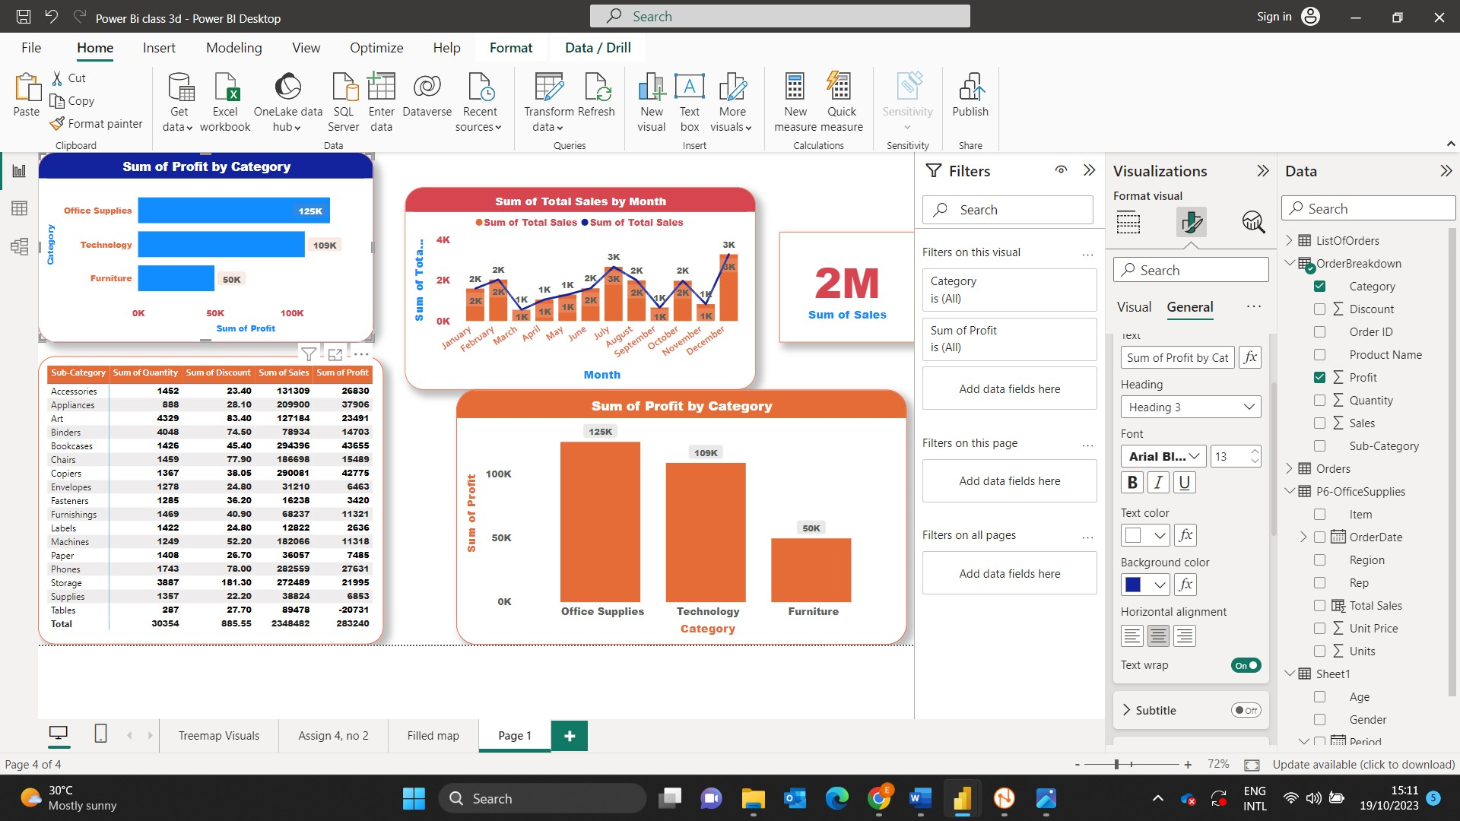

1. Make a report to analyze product sales using treemap visualization.

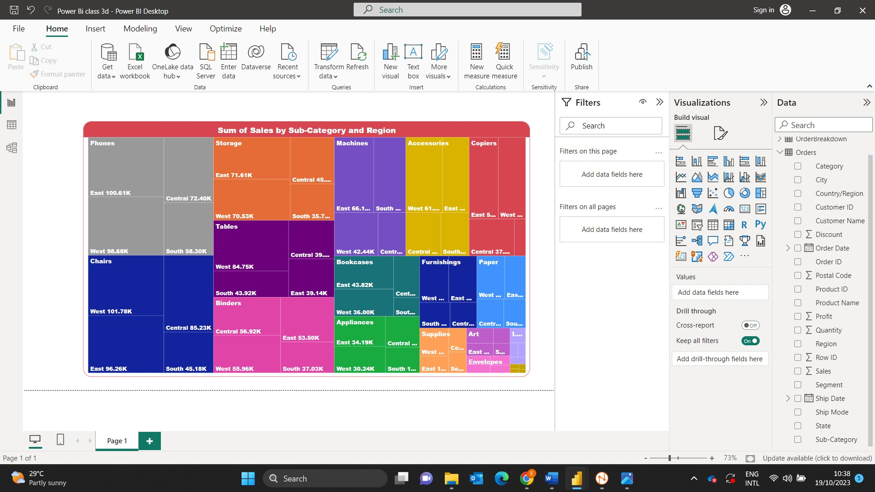

1. Make a dashboard on sales data (Minimum 4 tiles).

